A Gold- centered Approach to the Subsumption Process of Capital Circulation

Introduction
This document discusses Marx's analysis of the exchange process in bourgeois society, focusing on the subsumption of circulation over exchange, examining the significance of value metamorphosizes into commodities, money, and gold along the historical development of capital mode of reproduction. Giving special attention to the value metamorphosis to gold as the universal equivalent commodity, the money-commodity.
It is also merely another effort to develop Marx’s critique of the political economy of capitalism, particularly his theory on the so-called original accumulation as the historical foundation of capital reproduction. Grasping particularly into the metamorphosizes of commodities into money and of money into capital to understand the formation of the real capital form of value. It is hoarded gold historically concentrating an aliquot part of all the monetary-form of value realized into the mass of accumulated gold, as capital presented in its real value form simultaneously self-reproducing, multiplying, and constantly self-equivalent. The origine of the reproduction of capital is in the initial conditions of the circulation process.
Special attention is offered to the U.S. Dollar breakdown as hegemonic currency of the world-economy, stablished after the liberalization of gold commodity price. Nevertheless, gold still hold as real capital, the U.S. Dollar standard of price is being expressed yet in weighted gold after Bretton Woods finance policy reforms, but in a fixed proportion composing the current unit measure of monetary value, labeled as the dollar standard.

The subsumption of the exchange process to the circuit of capital reproduction
Marx traced the determinants of the circulation process particularly for bourgeois society in its initial conditions. The first determinant of the exchange process subsumption into the circuit of capital reproduction, is the determination of gold as the universal equivalent commodity, caused by the extension of the exchange process mediated by money, being gold money.
The second determinant corresponds to the transformation of gold, the money-commodity, into money-capital.
“[T]he process of circulation, therefore, unlike the direct exchange of products does not disappear from view, once the use-values have changed places and changed hands. The money does not vanish when it finally drops out of the series of metamorphoses undergone by a commodity. It always leaves behind a precipitate at a point in the arena of circulation vacated by the commodities. “Circulation [of commodities] sweats money from every pore”. %%[[KV1C3P208L4]]%%.
The circulation of money, on the other hand, is determined by the circulation of commodities, the circuit C-M-C always implies the constant removal of money (M) from the commodity-owner in its first metamorphosis (C-M) to the other commodity-owner (M-C). By this second metamorphosis money became a means of purchase.
“With this, the continuity of the movement depends entirely on the money, and the same movement which, for the commodity, includes two opposed processes, is, when considered as the movement of the money, always one and the same process, a constant change of places with commodities which are always different”.%%[[KV1C3P211L21]]%% %%[[KV1C3P210L18]][[KV1C3P210L26]][[KV1C3P211L10]][[KV1C3P213L1]]%%.
The circuit of money is the expression of the circuit of commodities. So, Marx raised the question about: how much money is being absorbed by the circulation of commodities? His answer introduced the circulation time as a determinant of the ratio between the velocity of the circulation of commodities and the velocity of circulation of money. As the quantity of total money absorbed as means for circulation is known by its equivalence to the total sum of the prices of all the commodities in circulation. If the total quantity of money circulating is determined by the total sum of prices of all commodities in circulation. Then, the circulation of the money-commodity (gold) is the expression of the total price of the commodities which exchange was mediated by money. %%[[KV1C3P213L3]][[KV1C3P216L2]][[KV1C3P216L30]]%%.
Furthermore, we can also raise the following interrogate: How much gold is being absorbed by the circulation of money? Its answer should be different from the response of the next one: How much gold is being expressed ideally by the sum of total prices of commodities circulating? The price of the quantity of money or the price of the money-commodity which is gold as means of circulation, is determined by the total sum of the prices of the commodities in circulation plus the average velocity of circulation (measured as the number of times the same piece of money turns-over within a given period. %%[[KV1C3P216L2]]%%. Fixing its use as a means of exchange, appearing in the process of circulation as a sign of magnitude for the quantitative equivalence of the exchange-value form of all the commodities, the universal equivalent commodity: gold. %[KV1C2P180L24]]%%.
The money-commodities of the formative period of the world economy: silver and gold were stolen from the indigenous continental territory (Abya-Yala) by the militarist colonial policy, in a magnitude constitutive of the so-labeled original accumulation. As the historical foundation of the reproduction scale in which the extended accumulation of capital has developed since then, from the initial conditions denoted by the invasion of “America”. It was the so-called primitive original accumulation of capital which extended the circulation of gold as money, defining the initial conditions and scope of the actual scale of its reproduction circuit, subsuming the exchange process to the social movement of money. So, the physical presence of money mined in the material form of indigenous alienable wealth, silver, was transformed into money-commodity when arrived at Europe, and then completed in China its metamorphosis into the elementary value form of gold for hoarding.
The following act on which the primitive performance of the money-commodity bearer took place was conditioned by the outcomes of the first metamorphosis. By which a certain degree of capital production was achieved due to the accelerated accumulation of the means of circulation correspondent to the sixteenth-century: gold and silver. The gold bearer can be seen in the following act, appearing in representation of gold, as if himself was not the merely replaceable but necessary form of appearance of gold in the circulation process. The commodity-money expresses and consumes an aliquot part of the exchange value of every commodity in circulation, signed and consumed by price. While historically concentrating an aliquot part of the price of each circulated commodity being consumed by its realization into the quantity of money signed by it –the commodity price (C). Ideally equivalent to the “quantity of labour objectified in it”, as measure of value.
Gold, as money-commodity and means of payment, was also fixed as the physical shape of the standard unit of price. So, the hoarder of gold, the representative of the commodity-money, has lived since created the money form of value; within the initial conditions which, by social accident, resulted in the extension of the exchange process, and its subsumption to the process of money circulation. %%[[KV1C3P193L1]][[KV1C3P194L13]]%%.
Gold is world money as the realized embodiment of capital. It is a measure of value, fixed unit standard of price, and real capital as at the same time [gold is] being constantly removed, separated, from the process of money circulation as a means of payment.
Until this point, with the compulsive subsumption of money circulation over the exchange process, money is used as a determinant of the “need to give an external expression to this opposition [between use-value and value which is latent in the nature of the commodity] for the purposes of commercial intercourse”. The upward scale shift of the exchange process mediated by money produced the drive toward the invention of an “independent” form of value, which finds neither rest nor peace until it became “independent from its own use-value”. %%[[KV1C2P182L34]]%%.
Indeed, the function of money as a means for circulation resulted from the inherent contradiction between the elementary form of use-value and its exchange-value, resolved by the creation of a new form of value which is the money-form (M), mediating the exchange of commodities (C-C). In that manner the differentiation of all commodities into commodities and money is completed. The value of every commodity is distinguished from its usefulness for exchange and signed with price, an imagined quantity of money valorized as an ideally equivalent quantity of expended human labour. %%[[KV1C3P198L16]]%%. %%[[KV1C3P188F1L1]]%%%%[[KV1C3P188L10]]%% %%[[KV1C3P199L14]]%%%%[[KV1C2P187L9]]%%.
So, why the indigenous alienable wealth became gold and silver, and were not anymore nor cattle neither slaves? Is because gold and silver, and not the slave, were already the social form of money when the super-exploitation of the indigenous peasantry in the silver and gold mines of “America” was planned and executed by colonization. Only after genocide and slavery follows the extension of the circulation process caused by the robbery of a magnitude of silver enough to being traded for gold in China, displacing gradually their rival money-commodities (silver and copper) as dual measures of value in the world-economy.
The mercantile capitalist found in silver and gold the “chief element of indigenous alienable wealth”. As values which don’t have use-value outside its exchange-value form. They treated gold and silver as commodity-money. But certain industrial capital was in formation, incorporating the value of labour into the valorization process of gold production as a commodity, in its circulation toward its money-form of value. Besides its circulation as a means of payment, gold is then produced for hoarding. %%[[KV1C2P183L18]]%%.
Gold mining was already a branch of production centralized in the hand of gold bearers mining production, before, during, and after the transition of mercantile capital into industrial and finance capital. So, the expanded circulation of gold as real capital, and mainly the state decision to use it as a means of circulation, as a universal equivalent, was not a social accident for the gold hoarders of the international state capitalists bank cartels (as the World Bank and the Monetary International Fund).
Those ones, the gold hoarders, then, later, configured the international bank cartels of state-capitalists, the class of world money bearers. Who as producers and hoarders of gold consume every other exchange-value using other means of circulation as metallized-money, monetized money, monetarized money or crypto-money. So, on avoiding the alienation of their gold hoarded into the process of circulation, as a means of payment. %%[[KV1C3P231L8]]%%.
The final instance of the exchange of commodities mediated by money (C-M-C) allows the consumption of use-values, only after its purchase introduce the commodities in a circulation process. The metamorphosis of commodities is a double process expressing, first the inherent contradiction in the commodity form, between use-value and exchange-value. And an external contradiction between the commodities and money. The value of commodities is ideally represented by price, while the money-commodity gold appears as the materialization of value. %%[[KV1C3P198L8]]%%.%%[[KV1C3P199L16]]%% %%[[KV1C3P198L29]]%%%%[[KV1C3P235L31]]%%.
“The difficulty lies not in comprehending that money is a commodity, but in discovering how, why and by what means a commodity becomes money.” “All the things are consumed by fire, and fire by all things, just as gold does for goods and goods for gold” (Herakleitos, Plutarch, Moralia, “The E at Delphi, 388D”). %%[[KV1C2P186L24]]%%.
Moore explained the social functions executed by money in the circulation process. First, by the examination of money as value measure, as the social incarnation of labour living time, expressed in the price-form of exchange value. But then money appears as the value-form of the common measure of value, living circulating labour-time. While being, at the same time, the hidden-form of appearance taken by gold in the circulation process, from which it is constantly separated as means of exchange. %%[[KV1C3P188L10]]%%%%[[KV1C3P199L10]]%%%%[[KV1C3P235L31]]%%.
The price of a commodity (C) is the money-form of value measured by an imaginary quantity of gold ideally equivalent to the labour-time socially necessary to produce the equivalent quantity of gold represented by the price of every commodity. The ideal measure of value, which is money, is measured in weighted gold. A fixed aliquot part of its elementary physical value-form, which is the standard of price defined by a fixed weight of gold. Indeed, as a measure of value, money serves only in an ideal capacity, as an imaginary quantity of gold equivalent to the abstractly necessary labour-time which is the common measure of all values. %%[[KV1C3P190L6]]%%%%[[KV1C3P192L5]]%%%%[KV1C3P195L20]][[KV1C3P196L24]]%%%%[[KV1C3P191L4]][[KV1C3P194L13]]%%.
Besides gold’s social function as value measure, being intrinsically money and commodity, at the same time. Gold is the standard of price, and therefore the privileged value of alienable wealth, production for hoarding. Being separated from the monetary form of value as means of circulation, in its elementary form, the physical value of gold. This separation of the money-form from the commodity-form of value, developed later in the liberalization of the money price from its elementary form as gold. Extending the dissociation between socially necessary labour time, as the common measure of value of commodities, and the money-form of value. %%[[KV1C3P189L1]]%%. %%[[KV1C3P197L1]]%% %%[[KV1C3P193L1]]%%.

Gold liberalization. Real capital production and distribution
After the 1971 international financial reforms, the U.S. Dollar became the hegemonic currency functioning as measure of value, separated from the price of gold and only lightly linked to an imaginary quantity of gold fixed as an aliquot part of the current measure of the standard of price. The liberalization of the price of gold immediately became the liberalization of the circulation of gold as a commodity, historically being the commodity-money. Divorcing the exchange-value measure of price from the value of gold as a commodity, as if it was any other commodity, being the money-commodity.
Gold liberalization due to institutional change extended exponentially the extractive frontier by the extension and intension of gold mining, extending the accountable pieces of the fixed unit value measure of price, the weighted gold hoarded by the international state banks such as the IMF, as well into the gold reserves of state-capitalists.
Under the actual conditions, gold is still hoarded as real capital. The contemporary implications of the liberalization of the price of gold are equivalent to the magnitude of the social accident of treating the elementary form of money, which is gold, the commodity that is not just a commodity because is simultaneously money, as if it was a mere commodity. As a potato in a sack of potatoes, and nothing else than a potato in a sack of potatoes.
Marx explained his concern relative to the quantitative incongruity and qualitative contradiction between the magnitude of value and its money-form (price). As inherent to the introduction of the price-form. “Hence the less the unit of measurement (here a quantity of gold) is subject to variation, the better the standard of price fulfils its office. But gold can serve as a measure of value only because it is itself a product of labour, and therefore potentially variable in-value”. %%[[KV1C3P192L20]]%%.
It’s because gold is produced as a commodity that has value and can function as standard of price. It’s not any material established by a mere Napoleonic authority as the elementary form of value measurement fixed in its weighted unity. Gold social movement can only ideally be abstracted from the development of value, as was explained by Marx using the idea of metamorphosis in which the inherent contradictions of the value form of commodities assume new forms of appearance. %%[[KV1C3P197L1]]%%. %%[[KV1C3P196L24]]%%.

After 1968-1971. Liberalization of gold price, gold reserves rush, and its fixed weight in the dollar standard of price
Gold was initially the medium of circulation, measure of value and the physical form of the standard price. The money-commodity “either in its own body or through a representative, is money. Gold (or silver) is therefore money”. So, only if paper-money represents gold is a symbol of value. Gold is first accumulated, as the outcome of the exchange of surplus-product converted into money, so hoarded in its money-commodity form, expressing the “superfluity or wealth” in the money form of value. %%[[KV1C3P225L28]]%%%%[[KV1C3P227L24]]%%.
Gold is, indeed, real money or real capital: the value materialization of the historically cumulated magnitude of exchange-value. Gold was separated from the total circulating money-capital by its muggers-hoarders-capitalists-bankers, the gold bearers; as the money-commodity in which an aliquot part of every exchanged value during a given turn-over time (for example, a year) is accumulated not only ideally, but materially. %%[[KV1C3P199L16]]%%.
Gold is still nowadays a fixed measure of the price-form. The exponential upward trend of its price is non-related to mining productivity or to the change in its variable capital composition. As the productivity of labour in mining reduced the variability of the amount of labour embodied in gold production to the minimum social necessary. When its price rises in an upward trend, the amount of its value possible to be absorbed by U.S. Dollars means of payment diminishes.
Diluting the social function of gold as standard of price, de facto being “fixed” to the U.S. Dollar money-form of value. Gold diminished its variation fixed in the current unit of value measurement, as a fixed aliquot part of the U.S. Dollar standard of price. But that stability is contradicted by the volatility of the U.S. Dollar, of the commodity price of gold, and of the price of gold reserves. Furthermore, gold is not money, it is the money-commodity. All the other commodities relate with gold as the means to express their money-form of value, in price.%% %%[[KV1C3P199L16]]%%%% %%[[KV1C3P199L20]]%%%%[[KV1C3P236L1]]%%%%[[KV1C3P202L1]]%%.
Gold hoarding developed in the separation of the money-commodity from circulation. Separated from the circulating capital, finance capital, productive capital, as means of circulation, gold is real capital. %%[[GNBIVP459L13]]%%. As soon as it appears in every instance of the circulation process without being used as means of payment, while still being present on it, constantly, consuming an aliquot part of every value realized by each circulation turn-over time. An aliquot part of the total surplus-value realized as profit, melted and hoarded in the elementary form of money-commodity, as gold fluidly distributed exclusively among gold bearers.
Melted in its gold mass accumulated, as the total capitalists wealth historically concentrating the maximum amount of the magnitude of surplus-value technically possible to be captured as profit in it elementary form of weighted gold (fixed as the standard unit of price), as a portion of the total cost-price (k) equivalent to the capital advanced in wages (variable capital, v) and capital advanced in non-human labour inputs as raw materials, instruments, machines, and means of production of machines (constant capital, c) during a given turn-over time.
In certain circumstances determined by the development of the production forces, due to the degree of scientific advancement in the productivity of gold mining, the total quantity of gold mined was relative to the amount of it required to accomplish its functions as money-commodity in the process of circulation. As value measure when it is the means of payment for major commerce transactions. And as the material of the standard unit of price fixed in a weighted quantity ideally equivalent to the magnitude of real value. The common measure of all values: being created by the living forces of production constituted by nature and humans.
Gold hoarding is exponential since 1971, but a crossover between 2006 and 2009 coincides with the substantive increasing also in China’s gold reserves, with a first gold considerable purchase in 2003.
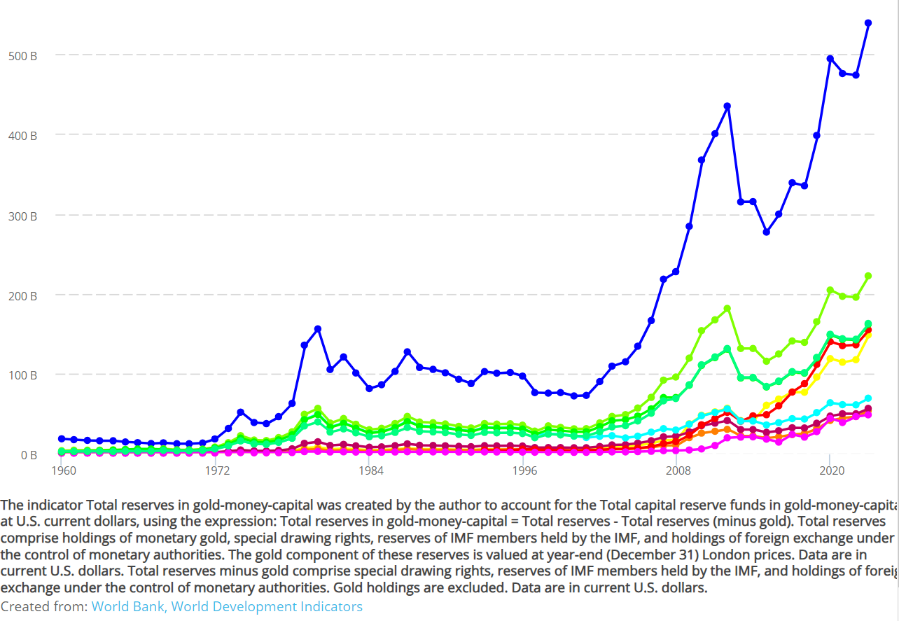
“Whenever there is a general disturbance of the mechanism, no matter what its cause, money suddenly and immediately changes over from its merely nominal shape, money of account, into hard cash”. %%[[KV1C3P236L5]]%%. The obstruction of the circuit of capital, and particularly of gold circulation, grows its necessity to hold on to its elementary form of money-commodity, being hoarded with strengthened voracity.
With the liberalization of gold price, since 1971, the total monetary system debased money from its elementary form. As if in that manner, the use-value of gold as the socially formed universally equivalent, would be suppressed, and replaced by certain specific currency (US Dollar), fixed by a hegemonic arrangement relying only on U.S. hegemony.

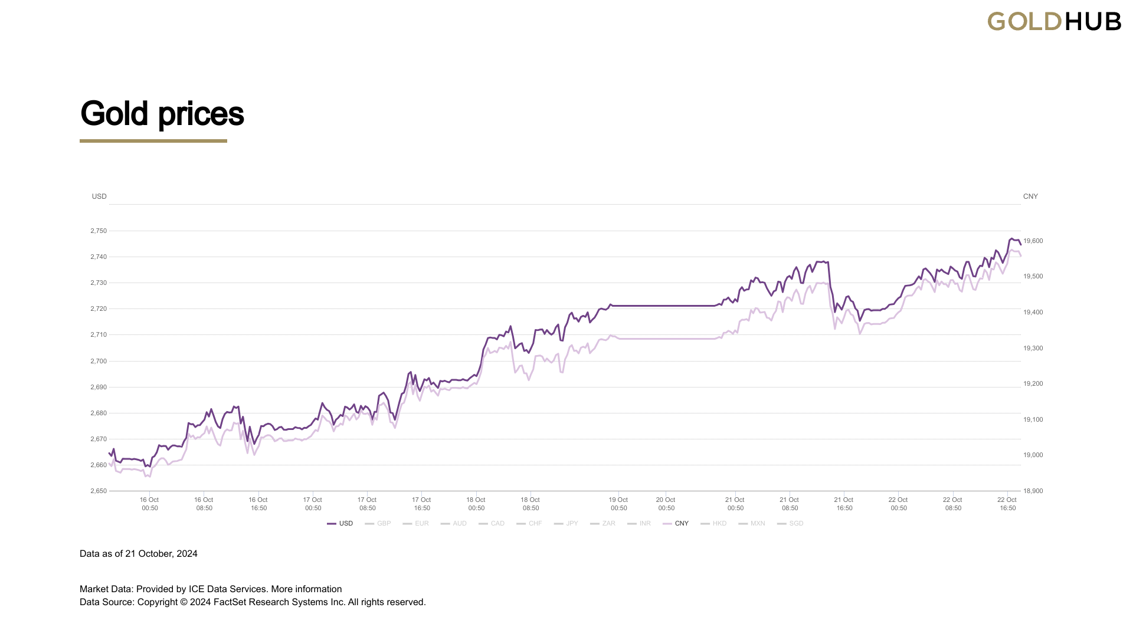

The liberalization of the price of money from its standard of price expressed in a fixed weight of gold as the elementary value form of money-commodity, raised the price of gold exponentially as well as propel another gold rush. But, as gold didn’t lose completely its properties, its physical properties as standard of price, central and international banks hoard it with extended voracity, while at the same time state capitalism is benefiting from the exponential upward of the gold-commodity price effecting in the exchange value of its national reserve gold fund.

Is the total sum of the different prices of the money-commodity circulating as world money expressing “the direct incarnation of all human labour” through the production of gold? Still considering gold production, the production of gold as a money-commodity, as the process on which the joint “social process of production in a purely atomistic way” %%[[KV1C2P187L20]]%% “assume a material shape [the gold standard of price]. [W]hich [appropriation] is independent of their control and their conscious individual action”. %%[[KV1C2P187L22]]%%. %%[[KV1C2P187L18]]%% . So gold is world money because it is “the directly social form of realization of human labour in the abstract”. %%[[KV1C3P241L1]]%%.
Indeed, the rise in the productivity of labor in gold production changed the quantity of the standard of value measure of money that is being produced by an equivalent abstract quantity of labor, while the price of gold growth exponentially as it is hoarded in its money-commodity form of value by the international finance state capitalists in reserves funds. As the circulation of the commodities and their transubstantiation into money are by their exchange scale, the chance of social accident by which the circuit M-C-M’ is being obstructed, mediate between the necessary conversion of commodities into money, correspondent to the process of transformation of surplus-value into profit.

Obstructive performances in anti-mining gold struggles. Interruptions in the velocity of capital circulation
Is it not in the transitional forms in which we should pay attention? What is to be done? Historically, the exchange process produced the accumulation of gold as a universal equivalent commodity which becomes world money: the exchange value of money physically expressed by gold.
Really, we know that the appropriation of gold is dependent on our control of the territories, cursed and not blessed by productive mines. The antimining struggles are in that sense, mediating between the chances and the social accidents which determine the realization of the accumulation of profits, produced by the exploitation of the total labour advanced in a certain period. Labour is in that sense, overdetermining the profit rate fall, not only as variable capital, but historically, getting back at the circulation process with the power of class struggle.
Also, while the imaginary, ideal, character of the money-form of value or price of the commodities, highlight the fictitious essence of money and its permanent expulsion from the circulation process of commodities (C-M-C); the relevance of the analysis of the standard of price for the study of the reproduction crisis of finance capital may be critical for the development of theoretical assumptions build over Marx’s critique to the political economy of the bourgeoisie society, considering the reforms to the gold standard of the international monetary system during 1968 and 1971, and its actual shift under the present critical juncture of transition to a new international monetary system, non-restricted by the dollar hegemony.
In this regard, the monetary crisis appears when the exchange value money-form (price) is raised, money is not required as measure of value nor as coin, but increases the price and volume of hoarded gold, as universal equivalent commodity. The quantity of money in circulation during a given period, such as a day, “no longer corresponds with the mass of commodities in circulation” %%[[KV1C3P237L20]]%%.

Conclusion
The development of capital as a form of value developed necessarily after gold was already money, and money circulation had already subsumed the exchange process. Marx studied the initial conditions of the circulation process and the historical development of capital reproduction process as a form of value. The historical juncture among the process of commodities exchange and money circulation is denoted as original accumulation, because it connotes the origine of capital as capital, as the alien organism subsuming nature forces into its self-reproductive metabolism. Only after the formation of “America” resultant from the colonization process by the methods of primitive accumulation, dispossession, and pure militarism; there is a world-economy; the subsumption process of capital operated since its initial conditions at the world-economy scale.
The reproduction metabolism development of the capital form of value is dependent on, or constrained by, the scale of the exchange process. It first relies on the production of a surplus product which becomes commodity-capital (C-M-C’), and, only after reaching that condition, then it functions as productive capital (measured as the total cost price) in the circuit of reproduction (M-C-M’). While capital is not always productive nor finance, as can be hoarded, it is real capital only if produces profits. Money, also, as capital, is organic in relation to capital, only if can bring real capital from the circuit of money circulation is functional for capital reproduction metabolism. Not all the money raised produced as a form of profit employing certain capital, can became capital, only the money which circulates as finance-productive capital, and the gold hoarded as real capital, are money-capital really. Overaccumulated money is not capital, until it becomes money that passes through the process of capital production.
Furthermore, gold’s significance as the elementary form of the measure unit of price increased incrementally since the formation of the world-economy, not only in its ideal measure of value, but in its physical value form, accumulating constantly in the hoarded mass of commodity-money, the surplus-value historically produced by the exploitation of nature, and living human labour. As the commodity price of gold rises at every instance of the circulation process, accumulating in its physical form, a fixed aliquot part of everything consumed by every exchange mediated by money. Indeed, raising the price of the gold reserves raises the price of money in proportion to the gold fixed standard of price. Then, the value of money increases, and with it comes a general inflation of all commodities in circulation. As a response to the increasing relevance of this issue for finance policy, the gold reserves rush is being pushed because of the total instability caused by the breakdown of U.S. world-hegemony on the international monetary system, precisely because of the overdetermination of the U.S. Dollar price on the standard of price. The trend of national and international gold reserves increasing its volume, particularly among the rival and challengers’ capitalist states contesting U.S. world-hegemony.

